|  |  |
| --- | --- |
| **Auteur(s):** |  |
| Jovi Simons  Sander Jochems |  |

|  |
| --- |
|  |
| Configuratieoverzicht |
| *Verkiezingssite* |

[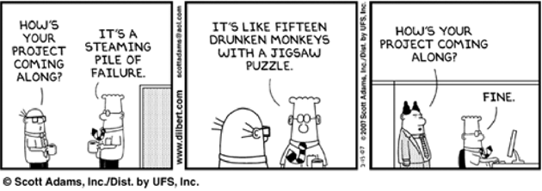](http://www.google.nl/url?sa=i&rct=j&q=&esrc=s&source=images&cd=&cad=rja&uact=8&ved=0ahUKEwj46a3X26LPAhXBoBQKHQITCSgQjRwIBw&url=http%3A%2F%2Farunkottolli.blogspot.com%2F2012_09_01_archive.html&bvm=bv.133387755,d.ZGg&psig=AFQjCNEuMwRJzUvAm2kVnQYQ-u33UUdg2A&ust=1474624737562039)

**Inhoud**

1. Te gebruiken hardware 3

2. Te gebruiken software 4

# 

# Te gebruiken hardware

|  |  |
| --- | --- |
| Apparaat | Vereisten |
| Laptop Jovi | I7 – 7700HQ  NVIDIA 1050 TI (4GB)  8 GB DDR4 RAM  128 GB  1 TB HDD |
| Laptop Sander | I5 – 7200U  NVIDIA 950M 2 GB  16 GB DDR4 RAM  256 GB SSD  1 TB HDD |

# Te gebruiken software

|  |  |  |
| --- | --- | --- |
| *Software* | *Versie* | *Opmerkingen* |
| Windows | 10 | User: Sander  User: Jovi |
| Visual Studio Code | 1.30.2 | Live Share (Extension) |
| GitHub | 1.6.1 |  |
| Word | 1901 |  |
| PHP Storm | 2017.2 |  |
| XAMPP | 3.2.2 |  |